# Town Meeting Guide



2023 Town Warrant

2023-24 Proposed Budget

## *Town of Merrimack, NH*

TABLE OF CONTENTS

# **Town Warrant** 2 -5

**(Article 2)**

**2022-23 Proposed Municipal Operating Budget** 6 – 10

Proposed 2022 Municipal Property Tax Rate 6

Budget Explanation 7 – 9

Default Budget 10

**(Article 3)**

**General Fund Capital Reserve Fund Deposits** 11

**(Article 4)**

**Wastewater Capital Reserve Fund Deposit** 12

**(Article 5)**

**Collective Bargaining Agreement -**   
 IAFF, Local 2904 13

**(Article 6)**

**Collective Bargaining Agreement -**   
 American Federation of State, County and Municipal Employees 93, Local 3657 14

**(Article 7)**

**Collective Bargaining Agreement -**   
 American Federation of State, County and Municipal Employees 93, Local 2986 15

**Tax Rate Summary** Inside back Cover

2023 Town Warrant

**Town of Merrimack**

6 Baboosic Lake Road, Merrimack, New Hampshire 03054

The State of New Hampshire

To the inhabitants of the Town of Merrimack in the County of Hillsborough in said state, qualified to vote in town affairs:

You are hereby notified that the First Session *(Deliberative)* of the Annual Meeting of the Town of Merrimack will be held at the Mastricola Upper Elementary School’s All-Purpose Room on 26 Baboosic Lake Road in said Merrimack on Wednesday, March 15, 2023 (snow date Friday, March 17, 2023), at 7:00 o’clock in the evening (pm) for explanation, discussion, and debate of each Warrant Article. Warrant Articles may be amended at this session per RSA 40:13, IV.

You are hereby notified that the Second Session *(Ballot Voting)* of the Annual Meeting of the Town of Merrimack will be held on Tuesday, April 11, 2023, at 7:00 o’clock in the forenoon (am) for the choice of town officers elected by official ballot, to vote on questions required by law to be inserted on the Official Ballot, and to vote on all Warrant Articles from the First Session on Official Ballot per RSA 40:13, VII. The polling places for the election of town officers, and other actions required to be inserted on the ballot, will open on said date at 7:00 o’clock in the forenoon (am) and will not close earlier than 7:00 o’clock in the evening (pm).

The three aforementioned polling places will be as follows:

James Mastricola Upper Elementary School All-Purpose Room, 26 Baboosic Lake Road

St. John Neumann Church, 708 Milford Road (Route 101A)

Merrimack Middle School, **31 Madeline Bennett Lane**

**Article 1**

To choose all necessary town officers for the ensuing year.

Two (2) Town Councilors 3-year term

Two (2) Library Trustee for a 3-year term

Two (2) Ethics Committee Member for a 3-year term

One (1) Trustee of Trust Funds for a 3-year term

**Article 2**

Shall the Town raise and appropriate as an operating budget, not including appropriations by special warrant articles and other appropriations voted separately, the amounts set forth on the budget posted with the warrant or as amended by vote of the first session, for the purposes set forth therein, totaling $38,791,564? Should this article be defeated, the default budget shall be $35,300,821, which is the same as last year, with certain adjustments required by previous action of the Town or by law; or the Town Council may hold one (1) special meeting, in accordance with RSA 40:13, X and XVI, to take up the issue of a revised operating budget only.

(Recommended by the Town Council 6-0-0) (Majority vote required.)

**Article 3**

To see if the town will vote to raise and appropriate the sum of $1,947,250 to be added to the following Capital Reserve/Expendable Trust Funds previously established for the purposes for which they were created and to apportion the sum among the several funds as listed below:



These appropriations are **not** included in the total town operating budget warrant article 2.

(Recommended by the Town Council 6-0-0) (Majority vote required.)

**Article 4**

To see if the town will vote to raise and appropriate the sum of $550,000 to be added to the Sewer Infrastructure Capital Reserve Fund previously established with said amount to come from sewer fees and no amount to come from taxation.

(Recommended by the Town Council 6-0-0) (Majority vote required.)

**Article 5**

Shall the Town of Merrimack vote to approve the cost items included in a collective bargaining agreement reached between the Merrimack Town Council and the IAFF, Local 2904, which calls for the following increases in salaries and benefits at the current staffing levels:

|  |  |
| --- | --- |
| **Fiscal**  **Year** | **Wage and Benefit**  **Costs Increase** |
| 2023-24 | $ 154,367 |
| 2024-25 | 106,788 |
| 2025-26 | 100,613 |

and further to raise and appropriate the sum of $154,367 for the current fiscal year, such sum representing the additional costs attributable to the increase in salaries and benefits required by the new agreement over those that would be paid at current staffing levels? This collective bargaining agreement covers the Firefighters and Paramedics of the Fire Department. (Recommended by the Town Council 6-0-0) (Majority vote required.)

**Article 6**

Shall the Town of Merrimack vote to approve the cost items included in a collective bargaining agreement reached between the Merrimack Town Council and the American Federation of State, County and Municipal Employees 93, Local 3657, which calls for the following increases in salaries and benefits at the current staffing levels:

|  |  |
| --- | --- |
| **Fiscal**  **Year** | **Wage and Benefit**  **Costs Increase** |
| 2023-24 | $ 153,941 |
| 2024-25 | 76,059 |
| 2025-26 | 80,757 |
| 2026-27 | 62,039 |

and further to raise and appropriate the sum of $153,941 for the current fiscal year, such sum representing the additional costs attributable to the increase in salaries and benefits required by the new agreement over those that would be paid at current staffing levels? This collective bargaining agreement covers the supervisory employees of the Fire and Police Departments. (Recommended by the Town Council 6-0-0) (Majority vote required.)

**Article 7**

Shall the Town of Merrimack vote to approve the cost items included in a collective bargaining agreement reached between the Merrimack Town Council and American Federation of State, County and Municipal Employees 93, Local 2986, which calls for the following increases in salaries and benefits at the current staffing levels:

|  |  |
| --- | --- |
| **Fiscal**  **Year** | **Wage and Benefit**  **Costs Increase** |
| 2023-24 | $ 162,748 |
| 2024-25 | 130,167 |
| 2025-26 | 82,414 |

and further to raise and appropriate the sum of $162,748 for the current fiscal year, such sum representing the additional costs attributable to the increase in salaries and benefits required by the new agreement over those that would be paid at current staffing levels? $59,980 towards the first year’s payment to come from sewer fees from the Waste Water Enterprise Fund. This collective bargaining agreement covers laborers of the Highway, Solid Waste Disposal, Wastewater Treatment, and Equipment Maintenance Divisions of the Public Works Department. (Recommended by the Town Council 6-0-0) (Majority vote required.)

**ARTICLE 2**

**Operating Budget**



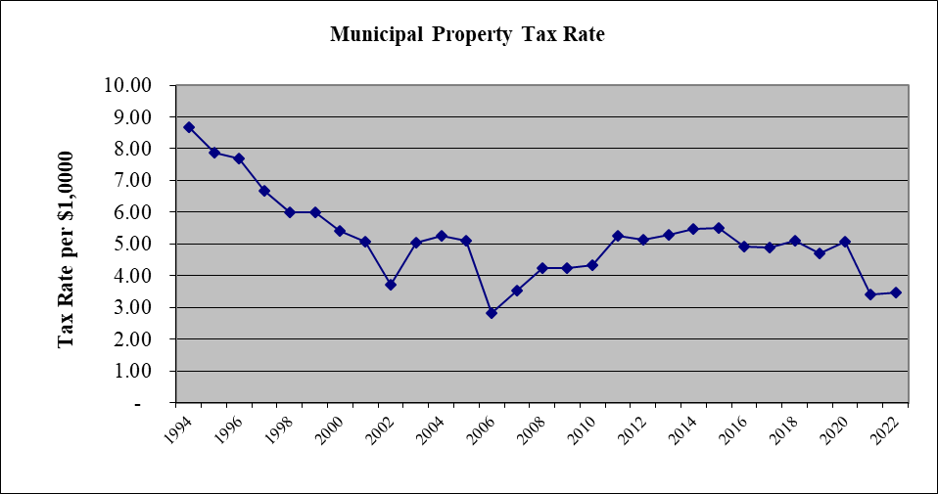









**Article 3**

**General Fund Deposits into Capital Reserve Funds**

These are deposits into General Fund Capital Reserve Funds (CRF) that in prior years had been included into the operating Budget. In recent years there was a change to RSA 35-5 that states we need to have a separate warrant article from the operating budget for CRF deposits. The chart below shows a comparison from the 2022-23 budget to the 2023-24 proposed budget.

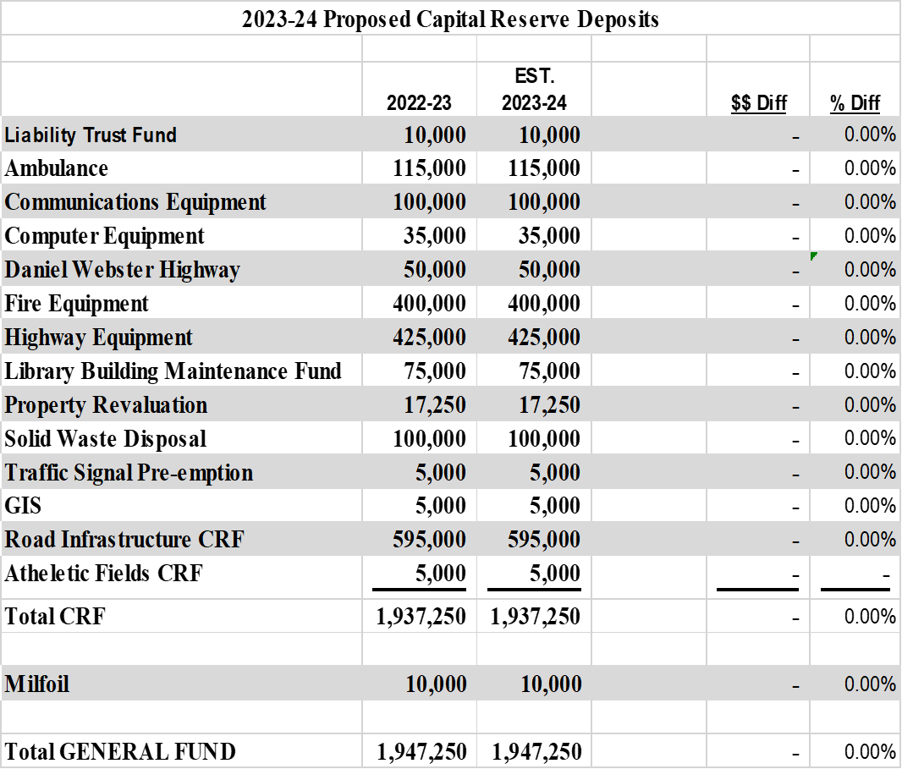

* Estimated Tax Rate Impact $.39

**Article 4**

**Sewer Fund Deposits into Capital Reserve Funds**

**Funding for Article 4 comes from sewer user fees, NOT TAXES.**

Like Article 3, Article 4 is the Sewer Fund (Waste Water Treatment Plant) deposits into the Capital Reserve Fund (CRF) that in prior years had been included into the operating Budget. In recent years there was a change to RSA 35-5 that states we need to have a separate warrant article from the operating budget for CRF deposits. The chart below shows a comparison from the 2022-23 budget to the 2023-24 proposed budget.

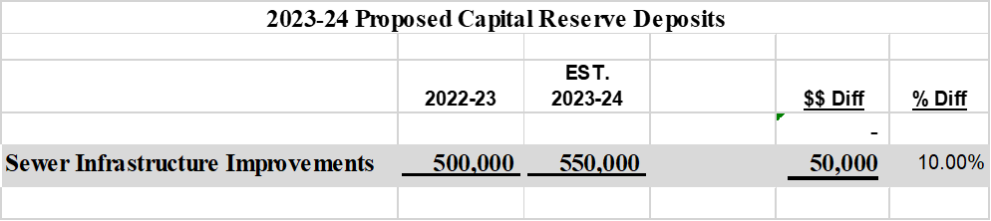

* Estimated Tax Rate Impact $.00

**Article 5**

**IAFF, Local 2904,** **Collective Bargaining Agreement**

**Firefighters**

The following shows the items agreed to:

1. **Duration:**

3-year contract – July 1, 2023 through June 30, 2026

1. **Wages**: 3.0% wage increase in Year 1 of the contract.

3.0% wage increase in Year 2 of the contract.

3.0% wage increase in Year 3 of the contract.

In addition, all union members will receive an increase to their base hourly rate of $0.10 per hour effective the first full pay period in July 2023. Also, certain stipends previously paid separately upon the achievement of certain certifications will be incorporated in the employee’s base rate of pay prior to the wage increase of 3% described above.

1. **Life Insurance:** – Benefit changes for employee increased from $10,000 to 1 times annual salary, spouse increased from $1,000 to $10,000, and children benefit increased from $500 to $5,000.
2. **Clothing Allowance:** Adjustments to the quantity of certain Town issued apparel and equipment upon beginning service and upon the completion of the probationary period, and a reduction in the prorated monthly allowance upon completion of the probationary period from $70 to $50.

* Estimated Tax Rate Impact $.03

**Article 6**

**AFSCME 93, Local 3657,** **Collective Bargaining Agreement**

**Police and Fire Supervisors**

The following shows the items agreed to:

1. **Duration:**

4-year contract – July 1, 2023 through June 30, 2027

1. **Wages**: 3.0% wage increase in Year 1 of the contract.

3.0% wage increase in Year 2 of the contract.

3.0% wage increase in Year 3 of the contract.

3.0% wage increase in Year 4 of the contract.

In addition, all union members will receive an increase to their base hourly rate of $2.00 per hour effective the first full pay period in July 2023 prior to the wage increase of 3% described above. In Year 2, Fire Captains will receive an additional increase of $1.50 per hour prior to the 3% increase described above. In Year 3, Fire Captains will receive an additional increase of $1.00 per hour and Police Supervisors will receive an increase of $0.50 per hour prior to the 3% increase described above. Also, certain stipends previously paid separately upon the achievement of certain certifications will be incorporated in the employee’s base rate of pay.

1. **Disability Insurance:** – The weekly benefit limit will increase from $600 to $700.

* Estimated Tax Rate Impact $.03

**Article 7**

**AFSCME 93, Local 2986,** **Collective Bargaining Agreement**

**Public Works Laborers**

The following shows the items agreed to:

1. **Duration:**

3-year contract – July 1, 2023 through June 30, 2026

1. **Wages**: 0.0% wage increase in Year 1 of the contract (see note below).

3.0% wage increase in Year 2 of the contract (see note below).

3.0% wage increase in Year 3 of the contract.

**Note: Adjustment of Wage Scale** -Year 1 - Steps 1 & 2 will be removed and the scale will slide to the left making the old step 3 the new step 1. There will be 2.5% adjustment between steps 7 and 8, and 8 and 9.

Year 2 – Step 1 will be removed and the scale will slide to the left making the old step 2 the new step 1. There will be 3% adjustment between steps 8 and 9. In addition, there is a 3% wage increase as stated above.

New Classification EOIII - Sewer Crew– Town will add Sewer Crew responsibilities to EOIII job description and add position in the pay scale $.50 above EOIII scale.

1. **Wastewater On-call -** Anyone hired, promoted, or transferred after February 1, 2023 into Wastewater positions that are needed to be on-call are required to be part of the on-call rotation.
2. **Life Insurance:** – Benefit changes for employee increased from $10,000 to 1 times annual salary, spouse increased from $1,000 to $10,000, and children benefit increased from $500 to $5,000.
3. **Disability Insurance:** – The weekly benefit limit will increase from $600 to $700.
4. **Holiday On-Call:** - Employees will be paid an extra 2 hours at 1.0 times their base hourly rate for each observed Holiday that the employee is required to be on-call.
5. **Clothing Allowance:** The Town will provide an allowance up to $85.00 for certain employees for approved prescription safety glasses once every 2 years.

* Estimated Tax Rate Impact $.02

**Tax Rate Summary:**

|  |  |  |
| --- | --- | --- |
| Article 2 | Operating Budget | $3.63 |
| Article 3&4 | Deposits into CRF | $0.39 |
| Article 5 | IAFF Local 2904 Collective Bargaining Agreement | $0.03 |
| Article 6 | AFSCME Local 2987 Collective Bargaining Agreement | $0.03 |
| Article 7 | AFSCME Local 3657 Collective Bargaining Agreement | $0.02 |
| Projected 2023 Tax Rate |  | $4.10 |
| 2022 Tax Rate |  | $3.86 |

In summary if all the 2023 Warrant Articles pass the Tax Rate for the Municipality’s portion is estimated to be an increase of $0.24 over the 2022 Tax Rate.  **IMPORTANT TOWN MEETING INFORMATION**

Merrimack operates under the Official Ballot Law. If you have any questions, please call the Town Council's Office at 424-2331.

**Session I: Deliberative Meeting**

This meeting is very important!!! It is not merely a public hearing; it is a session where every money article, and most others, can be amended. For example, a warrant article for $50,000 can be amended to read $1 or $250,000. Similarly, an article on the town warrant can be amended to alter its purpose and effect so long as the amendment does not delete the entire subject matter of the article. Yes, even petitioned warrant articles can be amended at this session.

It is the results of this meeting that will be on the Official Ballot, not the recommendations of the Town Council.

**Town Meeting Deliberative Session:**

# Wednesday, March 15, 2023, 7:00 p.m.

Mastricola Upper Elementary School All-Purpose Room.

**Session II: Ballot Vote**

**Any voter will be able to vote for all warrant** articles, as amended at Session I. Please be aware that, since the entire text of any proposed ordinances will appear on the ballot, the ballot may be quite long. Sample ballots will be available before Session II. Absentee ballots will be available for this session for those who qualify.

If the budget fails, the governing body may call a special meeting to take up the issue of a revised operating budget only (not other warrant articles). This would entail Session I and Session II, just as before. If the operating budget is again defeated, the default budget becomes the official budget for the year.

**Town Meeting Voting Session: Tuesday, April 11, 2023**

**Voting 7:00 a.m. through 7:00 p.m.**

**Locations- James Mastricola Upper Elementary School All-Purpose Room, 26 Baboosic Lake Road**

**St. John Neumann Church, 708 Milford Road (Route 101A)**

**Merrimack Middle School, 31 Madeline Bennett Lane**